Week 4 Programming assignment includes the following changes in my application:

In src:

Business class ServiceLoadException.java created

Domain class AvailableRoom.java modified

Service class ServiceFacotry.java modified

Service class IseeGalleryService.java modified

Service class seeGalleryServiceImpl.java modified

In test:

Service test class ServiceFactoryTest.java modified

Service test class seeGalleryServiceImplTest.java modified

Previous week correction:

Two-service folder in my project refactors to rename the package to make it one folder.

Execution result:

No compiler error:

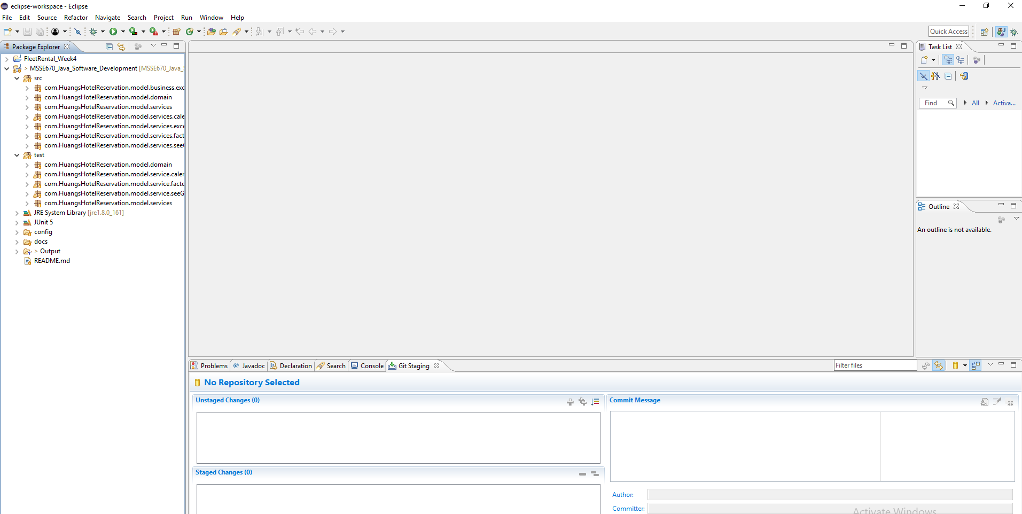

Execution of the service factory:

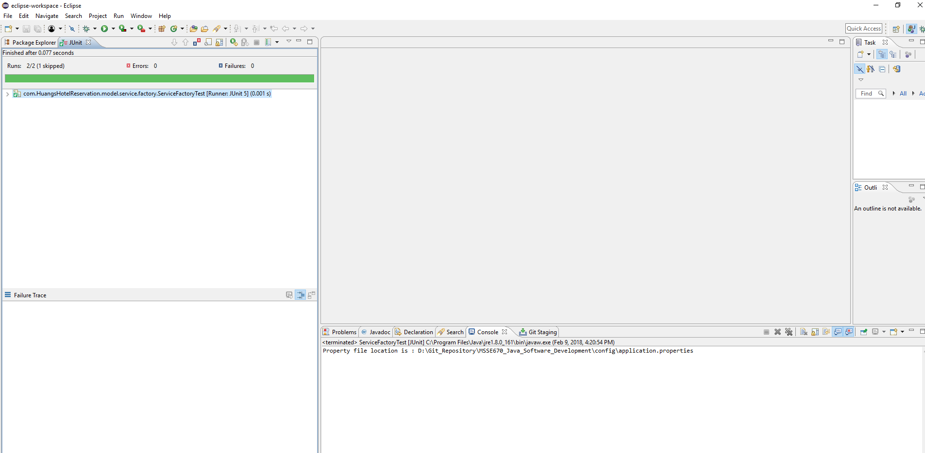

Sample of output:

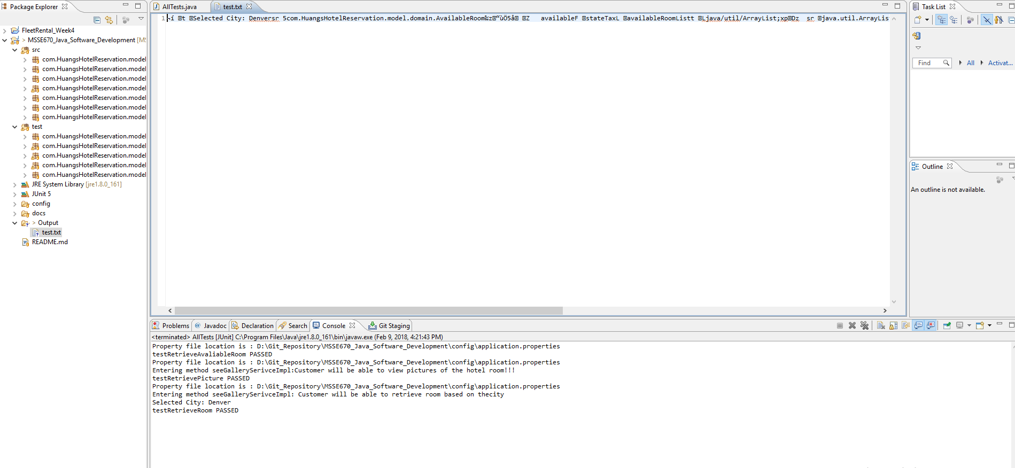

Execution of test suite:

